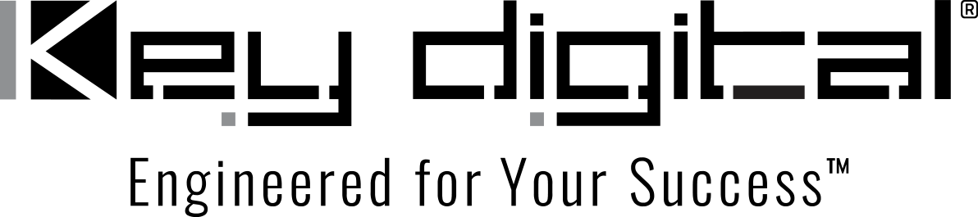

Contacts:

Key Digital

Masha Lakhter, COO

917.701.3238

masha@keydigital.com

Clyne Media, Inc.

Frank Wells, Senior Account Manager

615.585.0597

frank.wells@clynemedia.com

Key Digital KeyCode Open API enables third-party network control of external hardware

— The KeyCode Open API architecture native to Key Digital® controllers and control-equipped 4K AV over IP encoders/decoders offers an affordable and simple means of extending digital AV network control to non-networked devices through translation of networked text streams to RS-232 or IR commands —

MOUNT VERNON, NY, August 1, 2022 – Digital control, processing and signal distribution networks have revolutionized the AV systems industry for the better. Yet, many AV networking systems do not have the ability to control disparate external hardware components that lack network interface capabilities. “There is a simple, affordable solution to extending the control capabilities of such systems,” says Jonathon Ferry, VP of product education and experience at Key Digital®, an award-winning developer and manufacturer of leading-edge digital video processing, video signal distribution, collaboration and communications solutions.

“Key Digital offers a standalone controller, and video encoders and decoders with built-in controller functionality,” Ferry continues. “By means of our KeyCode Open API architecture, our hardware can control any device that accepts RS-232 or IR commands, such as video displays, projectors, motorized screens, cameras, cable/satellite TV boxes, lighting controllers, music players and thermostats, as well as our own hardware. The proprietary networked system simply sends a device command to a flexibly designated port as an ASCII text string via TCP/IP.” Key Digital hardware sharing the TCP/IP network can be configured to monitor a defined port, intercept and translate the text stream and deliver it to the target device via IR or RS-232. The bi-directional ports can also receive data, such as a command acknowledgement or status report, and return it to the source network.

This control capability is native to Key Digital’s KD-CX800 Controller and 4K AV over IP system encoders and decoders, all PoE-ready for ease of installation. The KD-CX800 Controller is a dedicated control-over-TCP/IP device with dual TCP/IP ports and three bi-directional control ports – one supporting IR out (emitter) and IR in (sensor or hardwire) and two multi-function ports supporting IR, RS-232, voltage trigger or voltage sensor operation. The flexible KD-CX800 can serve as a control gateway for Key Digital 4K AV Over IP systems, “enabling more third-party control options than other HD over IP systems,” says Ferry. What’s more, he adds, “Through support of generic RS-232 and IR command strings delivered via TCP/IP, “the KeyCode Open API brings cost-effective bi-directional control expansion to advanced third-party control systems and adds a reliable hardware interface to network-based control apps.” As a CAT-connected network device, the KD-CX800 by default can extend control signals up to 400ft / 121m.

Further, the robust API allows for bi-directional communication with third-party networked hardware implementing the Compass Control® Pro fully integrated iOS-based control system (developed by Key Digital and supported in hardware from more than 60 Compass Alliance partner brands) and also allows direct TCP/IP device control from iOS controllers with no ports used.

The CX800 Controller functionality is also available in Key Digital’s family of 4K UHD AV over IP HDMI-to-IP encoders and decoders. The KD-822ENC/DEC is equipped with a single TCP/IP port and one bi-directional IR port and one multi-function port. The KD-922ENC/DEC devices have the full CX800 feature set while adding audio de-embedding with Lip Sync control, audio pre-amp and video wall processing. The advanced-featured KD-1022ENC/DEC devices add independent video, audio and USB switching, audio control, video mosaic wall processing and KVM/USB extension and routing to the feature set. “These devices let users create matrixed 4K AV over AV systems of any size and level of sophistication with the benefit of third-party control of the system and external devices via the KeyCode Open API,” says Ferry.

“Audio-only networks can expand into video with Key Digital 4K AV over IP hardware and retain centralized control,” he elaborates. “Or, where a networked system simply needs to add control of a few external devices, one of our control-capable devices employing the KeyCode Open API provides an elegant solution that’s very simply implemented.”

For more information:
Key Digital
…ends 610 words

Photo File 1: KD-CX800.jpg
Photo Caption 1: Key Digital’s KD-CX800 Controller is a dedicated control-over-TCP/IP device with dual TCP/IP ports and three bi-directional control ports supporting IR and RS-232. The native KeyCode Open API brings cost-effective bi-directional control expansion of non-networked devices to third-party AV networks.

Photo File 2: KD-IP822ENC.jpg
Photo Caption 2: Key Digital 4K AV over IP hardware encoders, such as the KD-IP822ENC, have KeyCode Open API-enabled control capabilities built-in

Photo File 3: KD-IP922DEC.jpg
Photo Caption 3: Key Digital 4K AV over IP hardware decoders, such as the KD-IP922DEC, are also capable of controlling external devices from a third-party network by way of the native KeyCode Open API architecture

Photo File 4: IP922asController.jpg
Photo Caption 4: This usage example of external device control shows a 10x12 4K AV over IP matrix composed of Key Digital 4K AV over IP hardware encoders and decoders being utilized to operate a host of varied devices via RS-232, IR and voltage trigger

About Key Digital:
Established in 1999, Key Digital® designs and engineers intuitive digital A/V connectivity and control solutions that embody excellence. Key Digital delivers reliable, superior-quality, easily-implemented, versatile, high-performance products for corporate, education, government, house-of-worship, bar & restaurant, digital signage and residential A/V applications.

Founded by innovator Mike Tsinberg, holder of over 40 digital video and HDTV patents, Key Digital designs and engineers its products in-house at its USA headquarters in Mount Vernon, New York. The result of meticulous research, development and testing, Key Digital products showcase the company’s extensive, unparalleled technical knowledge and expertise, as well as its market-driven approach, serving as a partner to consultants, designers, and system integration firms in the A/V industry. Key Digital works as its clients’ extended engineering team, developing customized solutions for specific applications. Key Digital is an lnfoComm, CEDIA, CES, and NAHB award-winning manufacturer.

Key Digital, Engineered For Your Success™

For more information, visit our webpage at www.keydigital.com

Follow Key Digital on social media:

